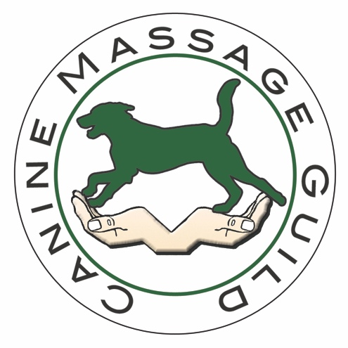

What Is Clinical Canine Massage?

Having trained for 2 years, Canine Massage Guild members use Clinical Canine Massage; a comprehensive system unlike any other.

It utilises Direct & Indirect Myofascial Release, Remedial Sports Massage, Deep Tissue Massage and Swedish Massage. What really sets this type of massage apart from others is the Lenton Method™; a set of direct myofascial release protocols designed specifically to suit the dogs anatomy, Bodymapping which is where the therapist learns common areas of muscular injury, myofascial pain and active trigger points and a systematic and scientific palpation routine which assesses muscles from complete origin and insertion to fibre direction.

Clinical canine massage involves assessment, manipulation and movement of the muscles and fascia to resolve or manage pain and dysfunction related to Soft Tissue Injury and to address the Protective Splinting of Muscles that occurs with Orthopaedic Issues.

The focus of Clinical Canine Massage is to work with Veterinary Diagnosed conditions to rehabilitate muscular dysfunction that is causing pain, restricting range of motion, inhibiting movement and affecting posture.

We work with Vets and Owners to assist in effective Pain Management and the rehabilitation of Muscular Dysfunction, Clinical Lameness and Signs of Subclinical Pain.

Quite simply there is nothing else like it. Let the results speak for themselves.

Clinical Canine Massage can be used to address and support:

Myalgia (muscle pain and weakness) Soft Tissue Injury (Strain & Sprain) Osteoarthritis – Hip Dysplasia – Elbow Dysplasia – OCD – Spondylosis – FCE – Intervertebral Disc Disease – Sciatica – Myofascial Pain (often seen as an exaggerated Panniculus Response) – Tendonitis – Trigger Points – CDRM – Neurological Inhibition – Somatic Dysfunction

What type of Canine Client is Clinical Canine Massage suitable for?
Senior – Ageing – Arthritic – Post Surgery (after 6 weeks) – Sporting – Working – Soft Tissue Injury – Pre Diagnosed Orthopaedic Conditions – Rehabilitation from injury – Neurological Issues – Mobility Issues – Weakness in Rear Legs – Intermittant Lameness – Dogs who have showed unremarkable or inconclusive X Rays – clients who cannot tolerate NSAIDS
Almost all dogs can benefit from clinical canine massage which is designed to help resolve common muscular issues such as Myofascial Pain and Trigger Points, rehabilitate soft tissue injuries such as the Strain and supports common orthopaedic conditions to restore or improve mobility, movement and manage pain.
What Is involved in a typical session
Full consultation – Dynamic Gait Analysis – Static Postural Analysis – Assessment via Palpation – approx 45-50 minutes Massage – Full Owner Feedback and Recommendations on Activities of Daily Living and External Living Environment that may be exacerbating the condition – 1.5 hours total for 1st appointment – 1 hour for follow up visits. All clients require Veterinary Consent in line with the Veterinary Act 1966 and Exemptions Order 2015.

How many sessions will the client need?
We work Best Practice and will do no more than an initial course of 3 treatments; in this time we expect to see tangible results as is set out by the human clients realistic expectations which is monitored through the course of treatment.
The client is reassessed on each visit. Should the therapy not be viable the client will be referred back to the vet.
We also assess the human client for ‘Owner Compliance’ to assess if they have been following the advice on Activities of Daily Living (ADL’s) needed to help manage or rehabilitate the condition.
We do not give potentially damaging and dangerous exercises eg: Swiss/Balance ball, wobble board/cushion. Instead we give solid sensible advice that will aid rather than hinder the dogs recovery. For example we will commonly advise owners to cover up laminate/slippy flooring with mats to prevent the joint from being put under consistent instability and to prevent slipping injuries to prevent the Strain-Restrain cycle. We want to address the cause rather than simply manage the issue.
How Is it done?
Students study for 2 years on the Therapeutic Canine Massage Diploma/Clinical Canine Massage Practitioner Programme with the internationally renowned Canine Massage Therapy Centre Ltd. to learn Canine Anatomy, Physiology, Gait Analysis, Common Orthopaedic Conditions and Pathologies, Neurological Conditions, Clinician Skills and 4 Disciplines of Massage:
Sports Massage – Not just for sporting dog but a remedial branch of massage designed to rehabilitate soft tissue injury and support areas of orthopaedic concern. Myalgia or Muscle Weakness, Scar tissue remodelling from the Strain, Trigger Point release, Hypertonia, Adhesions and restrictive tightness caused by protective muscle splinting associated with orthopaedic issues, are common issues addressed in Sports Massage. It’s focus lies on the therapist utilising their knowledge of Muscular Origins, Insertions and Actions, Fibre Direction, Muscle Identification and importantly Isolation, understanding the Action of the muscle and applying an appropriate range of techniques to rehabilitate the muscle.
Swedish Massage– Stimulates muscles to relax and soften, promotes Circulation and Lymphatic Drainage. Focuses mainly on superficial muscles.
Myofascial Release – Working on the 3D cobweb of the body which is now commonly being recognised as a secondary nervous system the Fascial Network is released to encourage normal somatic function, promote muscular strength and release habitual patterns of tension that cause or exacerbate pain. We do this using 2 Disciplines;
- Indirect Myofascial Release – a slow, gentle lengthy process whereby a Thixotrophic effect is gently exerted on the fascia, changed to ground substance then moved.
- Direct Myofascial Release – Addresses areas of somatic dysfunction of the Musculoskeletal system. Deep Fascia Sheaths (Endomysium) are released from the Periosteum that surround the bone to restore structural balance.
Deep Tissue Massage – a strong yet gentle discipline which works the tissue in tiers and levels allowing the therapist to access deeper underlying muscles. The therapist will allow the body to respond in between sessions ensuring that muscle is not directly overworked in 1 session
Lenton Method ™ - A three pronged approach that is registered, protected and totally unique to Canine Massage Guild Members. The therapist firstly learns a structured and scientific method of soft tissue assessment via advanced palpation skills. Bodymapping is used by the therapist to hone in exactly on common areas of soft tissue injury and fascial problems. Finally the therapist is taught a set of direct myofascial release protocols that return dysfunctional muscle and fascia to mobile, supple muscle in no more than 3 sessions. The results consistently speak for themselves.

Is there an Association for Massage Therapists?
The Canine Massage Guild accepts members on the basis they have successfully completed the 2 Year Training Course. The Guild are a Member of the Massage and Soft Tissue Group (MAST) who are currently working with DEFRA and LANTRA (the Land and Skills Agency) which in turn is feeding into the RCVS as part of the Review of Minor Procedures Regime Project. Members of the guild must complete 25 hours per year of CPD.

