Category 7: Case Studies – It’s time to take the Guild from good to GREAT!

The Guild wants you to be recognised for all the hard work that you do making positive changes to dogs lives. It’s such a life changing therapy for many dogs and even those with regular maintenance sessions come for a reason. We want to help to bring it to the forefront with a little help from you…..

Change in Guild Policy - for the good of you, potential clients, helping vets to understand, the industry and raising awareness of this amazing therapy.

A recommended Case Study or Blog to be written by each member once every 2 years ….

Why? The Rationale…

Our Community
If everyone writes just 1 case study, once every 2 years it means we have approx. 45 of them.
That means we have a potential waterfall of case studies/blogs that benefits everyone. So for 1 case study or blog you get the exposure of everyone else’s too! WOW!

Case studies are stronger than any advert so let’s work together to create something amazing….

If you are wondering why Mctimoney, hydrotherapy and physio get more recognition it’s because many make it mandatory for therapists to write up case studies for dissemination to media, social media and to vets. To bring the Guild up to another level and get it the recognition it deserves we’ve decided to adopt this approach too.

Other therapies will also commonly use case studies during presentations or communications with vets. I believe that every therapist has a major success story be it on a daily/weekly/monthly basis depending on the number of clients they see so we need to be sharing the results we get with…. well anyone who will listen! It could be getting a dog back from injury, helping them manage chronic pain, enhancing their life, reducing their anxiety….so many benefits…only you as an individual will know which case studies and results are suitable.

It’s about time that Clinical Canine Massage became more mainstream but without sacrificing our ethics don’t you think? I do.

I constantly hear about the amazing things you have done for dogs in person, how you have felt a level of excitement, elation, pride and quite simply joy at seeing the dog underneath your hands change for the better. The owners elation and the dogs improvement in quality of life.... It’s time to share the results. Not only will it give you CPD points but importantly more people will be able to recognise their own dog within a case study.

The Guild can’t do this without the help of every individual but we don’t expect you to do it for nothing so there’s also CPD points to gain too.

Be a part of something big and I thank you in advance for helping with this new exciting, strategic venture to bring awareness to your own business and the Guild as whole.

Best of wishes
Natalie Lenton

WOULD YOU LIKE TO GET INVOLVED WITH PROOF READING? Quite often people will say ‘if there is anything I can do to help….’ Well, yes please… those of you with a keen eye to volunteer to read over the submitted case studies will be so gratefully received. If every person asks just one of their Guild member colleagues and friends to read their work it will make this goal achievable

On average a typical Guild Blog on Facebook will reach around 5,600 people.

Taking 5,600 people as an average that means

If 90 case studies are produced

A total of
252,000

will see our community effort of case studies!
And that doesn’t take into account further shares or print in Our Dogs Newspaper who will regularly print our blogs!
WOW!

ut quosdam quaestum
Givers Gain

Case studies help to prove to members of the public, your future clients and a wider future audience that this therapy works. Also, vets love case studies, it’s the main thing they will look for to see if your therapy gets results which makes obvious sense and only you can communicate your results. The result for you: more business, simple.

It is recommended that each member submit 1 case study OR blog (or both if you wish to say more) once every 2 years.

HOW TO WRITE IT

- Write it as an inspirational story (use photos – a must. If you have a dog on video before and after you can use that too but this doesn’t count as a full video which needs to be edited together with text)
- Write it as a Formal Case study (see template)
- Write it blog style e.g.: 5 ways that this dog improved after canine massage, how this dog’s life changed after canine massage, this dog’s life changed after clinical canine massage (your results need to match your title) etc.…
- Produce a short video (8 points)
- Or maybe you have your own innovative idea
- Have fun doing this it’s your chance to tell the world about your therapy and how you have made a difference. The success you have with one dog can lead to other new clients
- You should always include pictures e.g.: dog before and after if this can be seen, photo of the dog and owner (make sure owner is happy for their photo to be used) photo of you massaging the dog (this should be hi res), make sure your hands are in an appropriate place! Pose for it rather than the client taking the photo when you are massaging, this doesn’t mean you have to cheesy grin for the camera although that is nice too. You can look like you are hard at work too.
- You should always include a quote from the client and if possible and you have the right relationship, a quote from the vet (you must check they are ok with their statement being published)
- You should distinguish your therapy from just ‘canine massage’ remember you are a clinical therapist who has trained for 2 years and you use the 4 disciplines plus the Lenton Method™ which is now officially trademarked. This is what makes your therapy different and sets you apart from someone who has done a poor course or who is just ‘rubbing their dog over’ at home. If you use other therapies combined with this you can always include that too! After all we all have our own unique approach.
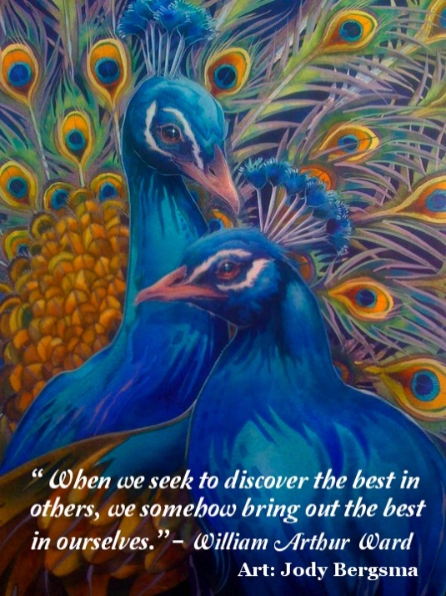
- You should proof read it and get someone else to as well. You have one chance to make an impact on your audience so make it count.
- Tips for an exciting blog or case study name:
http://www.twelveskip.com/guide/blogging/1247/blog-post-title-templates-that-work

Enjoy it. You should enjoy sharing your success!

Options:

- Case study with photos – 4 points (max of 8 points per year if you submit more)
- Case study with videos before and after (must be viewable, must not be 30 seconds long ideally around 3- 4 minutes– must be submitted edited together as before and after for publishing on Guild site and FB page, further details to follow) 8 CPD points
- 1 video plus 1 case study (max of 12 points per year)

Be a part of something big and I thank you in advance for helping with this new strategic venture to bring awareness to your own business and the Guild as a whole but especially raising awareness for dog owners who will bring in their own dog for your special brand of therapy.

I believe that everyone has a major success story on a daily/weekly/monthly basis depending on the number of clients you see so now it’s time to let the world know the fruits of your labour.

Edit your own copy…

A case study should be between around 400-800 words

Professional level writing is a must.

Sorry but…..Case studies that are submitted with poor or no terminology, incorrect spelling and poor grammar will not be counted. With much kindness, we state that committee members are not able to spend hours editing your work, spelling and grammar which as you can imagine is very time consuming with the number of members, so please get someone to read it through before you submit it.

Importantly……. Ask yourself; is this inspirational? Does it have value? To what niche of dogs? Vets/owners? Have I got across the results in a clear and concise way? If I read this would it make me sit up and take notice.

The case study should ideally be one of those cases that really stands out for you in terms of results.

- Name, age, breed
- Presenting issue, what did the owner say? How was the dog presenting? E.g.: Any of the 5 Pillars
- Any veterinary diagnosis? MRI? X Ray? Unremarkable x rays e.g.; they showed nothing!
- Main Findings e.g.: you will need to simplify slightly so may state Grade 2 Scar tissue as a result of the muscular issue the Strain. Myofascial pain, Trigger points etc... Only a 1 or 2-word sentence needs to describe this condition (if any) as we will link your issue to conditions listed on the Guild page. If you are wish to write at a higher level with more terminology just ensure you put in brackets a layman’s term too for easy reading.
- Owner quote/s
- Quote from yourself
- Always state you are a clinical canine massage therapist. You may also choose to include the names of other CPD you have done that you used e.g.: Lymphatic drainage, facilitated stretching, deep tissue, neuromuscular refacilitation (advanced trigger point, ventral aspect releases)
- All case studies should include photos e.g.: of you massaging dog (make sure you smile and pose for the photo rather than having it done in the middle of a massage as it can look quite odd otherwise)

WORK SMART – your case study will of course be used by the Guild. But you can also use it on your own website, Facebook page, local and other media. There is no harm in your case study being distributed across several media for your benefit.

A case study with photos is worth 4 CPD points. (2-4 photos recommended)

A case study with before and after videos of the dog moving is worth 8 CPD points. The videos should be clear and should consist of the dog in walk then trot then trot to canter. The video may also include text too e.g.: November 2016 – Barkley had been lame for 3 months, had tried physio, hydrotherapy, nsaids etc…. still he couldn’t walk normally…After 3 clinical canine massage sessions with canine massage Guild member Nicola Smith of Dog Therapy this is what happened…cue dog walking normally. Hopefully you get the idea.

The case study should be written to inspire others to get their dog massaged, to show the results you get and to get good attention from the veterinary community.

Case studies also provide an outlet for discussion with others via the Facebook Group; remember we can all learn from each other and that is a wonderful thing.

TEMPLATE

NAME
AGE
BREED

PRESENTING ISSUE e.g.: Hip dysplasia. Osteoarthritis. Slowing down. Not able to go on walks. Anxious. Think 5 PILLARS

REASON FOR MASSAGE – this is what the owner would like to see. Ideally this should always correlate with your results. You can insert here a quote from the owner/vet

WHAT HAPPENED DURING TREATMENT: HOW DID THE DOG RESPOND TO YOUR TOUCH
Now, keep in mind that we all know that not all dogs settle immediately and this is good to state that the dog became more accepting of touch too. Equivocally some dogs settle like a charm. You can insert a quote from yourself here and/or owner

FINDINGS Do your findings correlate with the reason for massage? e.g.: A strain, which is a tear to the muscle, was palpated during treatment. This commonly causes weakness to the hip joint and as Fido was showing a reduced ROM on his back left leg I used a set of sports massage techniques to remodel the scar tissue to improve the muscles ability to work correctly. I used the Lenton Method of 7 Direct Myofascial Release Protocols etc.. Over how many sessions?

RESULTS – you need to go to town on this.
What did the owner see?
What did you see?
How does the dog show the results?
A QUOTE FROM THE OWNER IS A MUST.

CONCLUSION: An inspirational single paragraph that concludes how you/owner felt and how the dog responded.

ADD YOUR NAME, BUSIINESS NAME, LOCATION, FOLLOWED BY CANINE MASSAGE GUILD MEMBER

Remember: the Guild strapline is RESULTS YOU CAN SEE AND YOUR DOG CAN FEEL IN 1-3 SESSIONS so your case study should reflect this.

ALSO – please remember this is a basic template and you are welcome to write it differently as long as it includes all of the information. See the article below for an example written by Jenny Youdan from Canine Elements.

